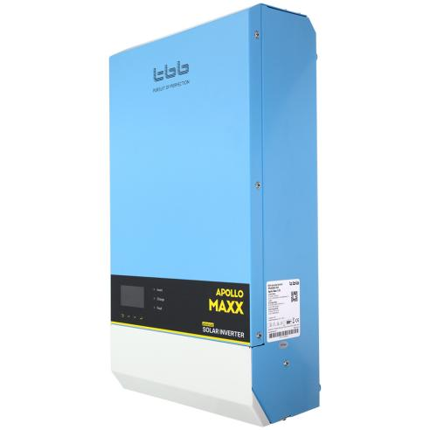
TBB Apollo Maxx series advanced photovoltaic inverter control all-in-one machine (supporting parallel three-phase)
Advanced All in One Solar Inverter With parallel and three phase capability Apollo Maxx 2KW-5KW,Apollo Maxx is a powerful all in one solar inverter that integrates with multiple functions, including a high-performance true sine wave inverter, a powerful battery charger,a MPPTcharge controller,a high-speed automatic transfer switch and two outputs for load management.
Apollo Maxx 2.0M Apollo Maxx3.0M
Apollo Maxx 2.0S Apollo Maxx3.0S
Apollo Maxx5.0S

---------------------------------------------------------------------------------------------------------------------------------
Product parameters Application Featured Services Certificate&Shipping
Features
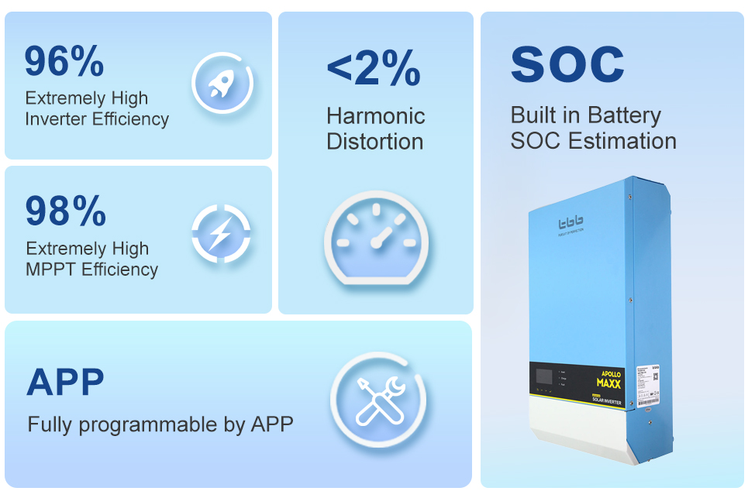Product Details

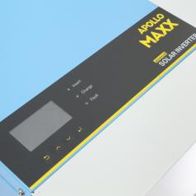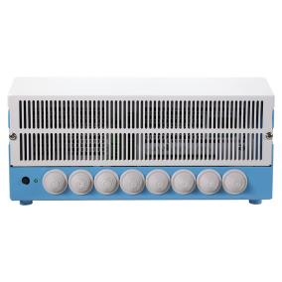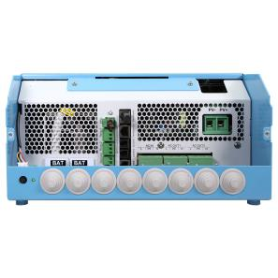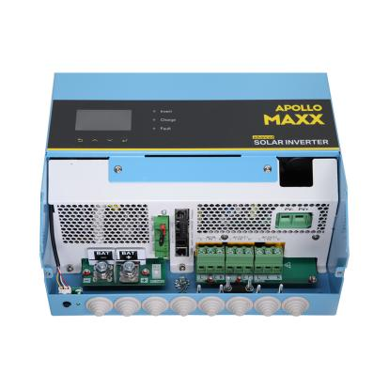
Product parameters
Model No. | Apollo Maxx2.0M | Apollo Maxx3.0M | Apollo Maxx2.0S | Apollo Maxx3.0S | Apollo Maxx5.0S
Product Topology | Transformer based
Power Assist | Yes
Parallel & Three Phase | Yes
AC input range | 175~265VAC(45~65Hz)
AC input Current (transfer switch)(A) | 32 |  |  |  | 50

Nominal battery voltage (M) 24 |  |  | 48
Input voltage range (V) 21~34 42~68
AC output voltage (VAC) 220/230/240±2%
AC output Frequency (Hz) 50/60±0.1%
Harmonic distortion <2%
Load Powerfactor 1.0
Cont.output power at 25℃(VA) | 2000 | 3000 | 2000 | 3000 | 5000
Max output power at 25℃(M) | 2000 | 3000 | 2000 | 3000 | 5000
Peak power(5 sec)(M) | 6000 | 9000 | 6000 | 9000 | 15000
Surge | 300%
Maximum efficiency | 94% | 94% | 95% | 95% | 96%
Zero load power (M) | 11 | 14 | 11 | 14 | 21
Max output current(A) | 60 |  | 60 | 60 | 60 |  | 90
Maximum PV power (M) | 2000 |  | 2000 | 4000 | 4000 |  | 6000
PV open circuit voltage (M) | 150
MPPTvoltage range (M | 65~145
Max.Py short circuit current (A) | 18 | 18 |  | 35 |  | 35 |  | 54
Charge voltage'absorption'(V) | 28.8 |  |  | 57.6
Charge voltage 'float'(V) | 27.6 |  |  | 55.2
MPPT charger maximum efficiency | 98%
MPPTefficiency | >99.5%
Protection | a) output short circuit; b) overload; c) battery voltage too high  d) battery voltage too low; e) temperature too high; f) input voltage out of range

-------------------------------------------------------------------------------------------------------
2.
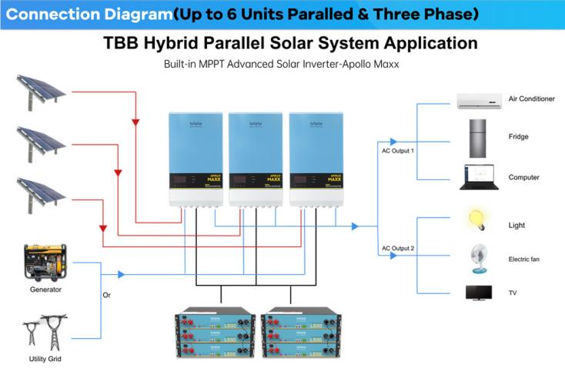

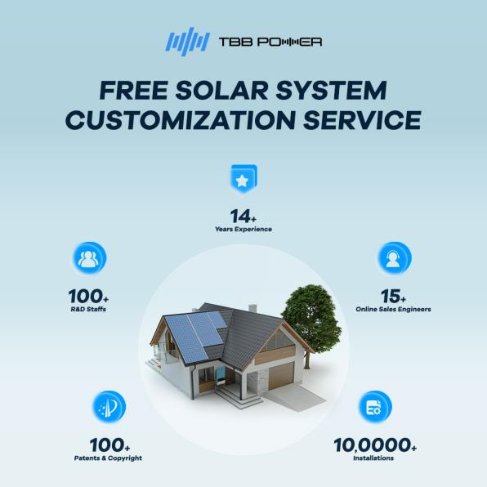

------------------------------------------------------------------------------------------------------------------------------
3.servive

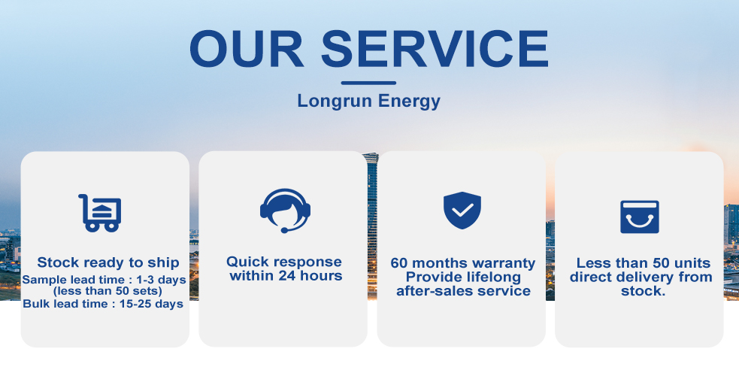

OEM/ODM
Product label
Longrun prides itself on helping customers enhance their
private label product lines.Whether you need help creating
the right formula or have a range of products you want to
compete with, we can help you deliver high-quality products
every time.
Packing of contract
Longrun can also be an extension of your company If
you already have an amazing product but can’t package
and ship it exactly as you want.We offer contract packaging
that can easily fill gaps in areas of your business that you
cannot currently complete

FAQS
1.Can I have my own custom design for products and packaging?
Yes, you can use OEM according to your needs. Just give us the artwork you designed
2.What’s the lead time for mass production？
-- It depends on the actual situation. 48V100ah LFP battery pack,3-7 days with stock, if without stock, that will be depends on your order quantity, normally needs 20-25 days.
3.How's your quality control system?
-- 100% PCM test by IQC.
-- 100% Capacity test by OQC.
4.How's the lead time and services?
-- Fast Delivery in 10 days.
-- 8h response & 48h solution.

.-------------------------------------------------------------------------------------------------------------------------------------------------------------------------------------
4.
At present, the company is vigorously expanding its overseas market and making a global layout. In the next three years, we are committed to becoming one of the top ten new energy battery export enterprises in China, serving the world with high-quality products, and achieving win-win results with more customers.
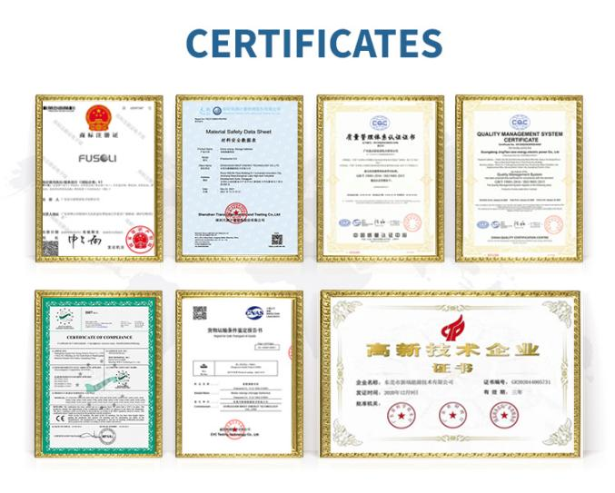

·Delivery within 48 hours
----------------------------------------------------------------
FAQS
1.Can I have my own custom design for products and packaging?
Yes, you can use OEM according to your needs. Just give us the artwork you designed
2.What’s the lead time for mass production？
-- It depends on the actual situation. 48V100ah LFP battery pack,3-7 days with stock, if without stock, that will be depends on your order quantity, normally needs 20-25 days.
3.How's your quality control system?
-- 100% PCM test by IQC.
-- 100% Capacity test by OQC.
4.How's the lead time and services?
-- Fast Delivery in 10 days.
-- 8h response & 48h solution.

